Cells
Put the following words into the correct space: bigger, building, microscope and organelles.
Cells are the ___________________ blocks of all living things.
Cells can be seen with a _______________________.
Magnification means making something look _____________________.
The small parts inside a cell are called ___________________________.

Use the following words to label the diagram of a microscope: stage, eyepiece, objective lens, barrel, base, mirror, arm, course focus knob, fine focus knob.
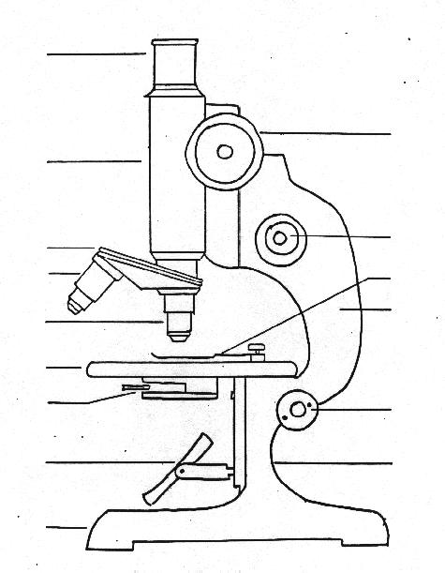

Cell Colouring Acitivity
Onto the diagram below do the following colouring:
Cell wall Blue
Cell membrane grey pencil
Nucleus red
Mitochondria Yellow

Chloroplast green
Ribosomes Purple
Plant Cell
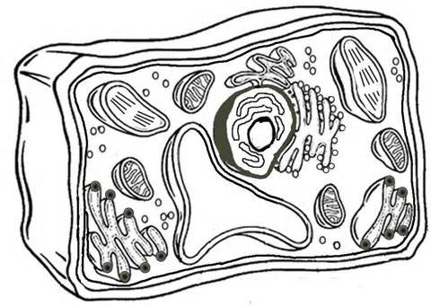
Which organelles do plant cells have that animal cells do not have?
Label this diagram
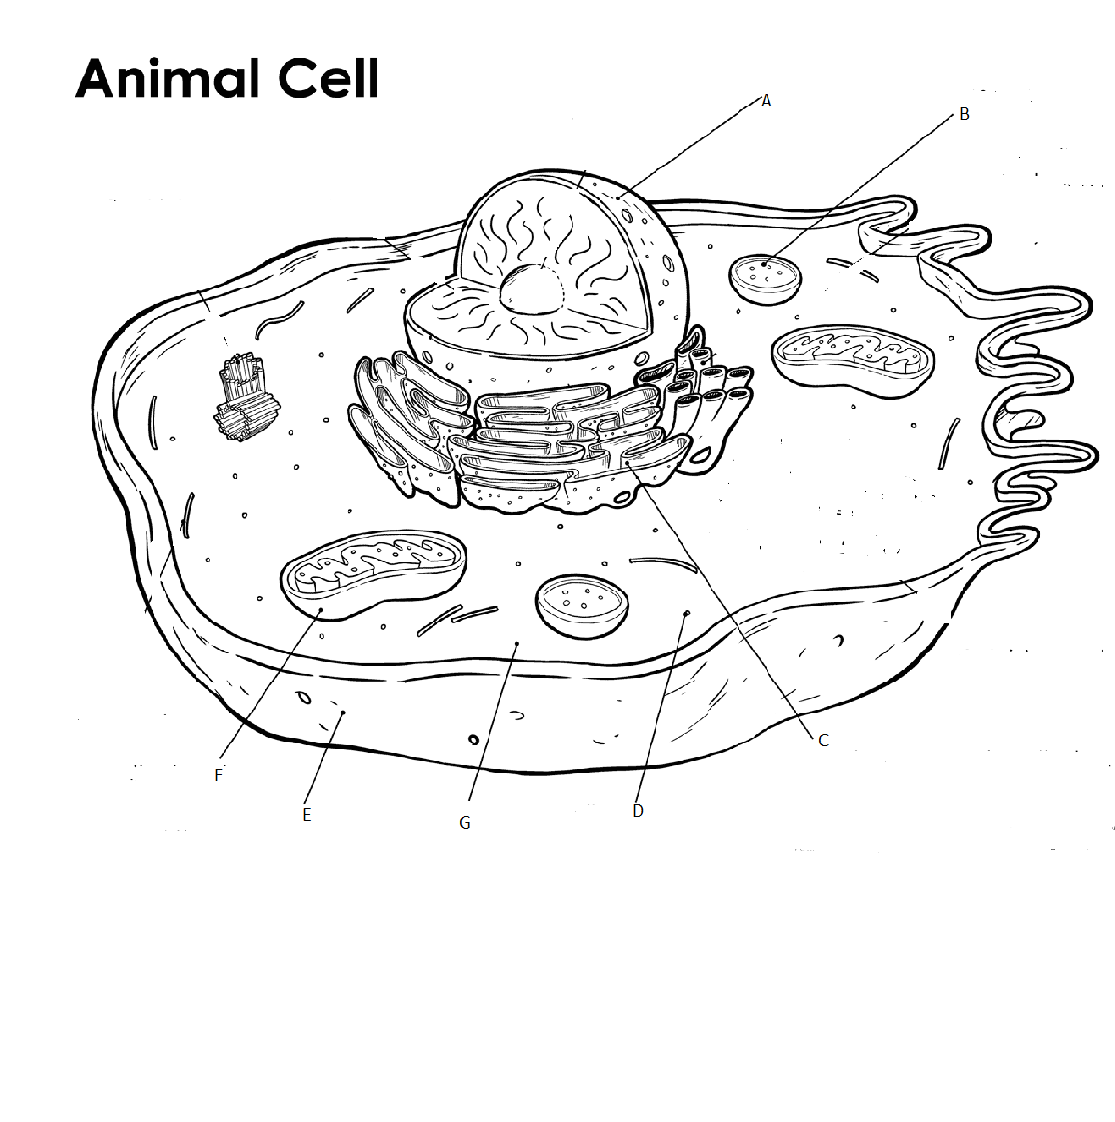

Cells

M | N | M | A | E | F | R | U | O | O | Q | N | J | S | E
B | I | T | P | V | S | K | I | R | B | U | Q | I | D | N
U | P | T | F | I | X | T | G | B | C | H | S | I | M | D
I | I | J | O | T | L | A | A | L | O | E | L | S | L | O
L | L | A | W | C | N | S | E | G | H | S | A | N | E | P
D | S | K | H | E | H | U | R | T | E | L | O | F | N | L
I | L | K | L | J | S | O | N | E | P | N | I | M | S | A
N | L | L | C | B | E | Y | N | O | V | L | F | A | E | S
G | E | N | B | O | S | S | T | D | F | O | C | U | S | M
S | C | E | U | O | L | Y | A | P | R | W | C | B | R | I
P | E | J | T | H | C | B | L | B | X | I | S | V | H | C
E | P | O | C | S | O | R | C | I | M | A | A | M | E | K
I | H | M | A | G | N | I | F | I | C | A | T | I | O | N
P | M | E | M | B | R | A | N | E | L | I | C | N | E | P
U | D | F | F | N | B | K | C | T | R | O | U | N | F | X

BASE | BLOCKS | BUILDING
CELLS | COVERSLIP | CYTOPLASM
ENDOPLASMIC | FOCUS | LENS
LIFE | MAGNIFICATION | MEMBRANE
MICROSCOPE | MITOCHONDRIA | NUCLEUS
OBJECTIVE | ORGANELLES | PENCIL
PHOTOSYNTHESIS | RIBOSOME | SLIDE
STAGE | WALL

